Heart Disease Analysis Project Documentation

TEAM MEMBERS:

1. MUKUL KASHYAP (CSE-C)
2. MOHD. SHAIFEE (CSE-C)
3. MOHD. ZEESHAN KHAN (CSE-C)

1. Introduction
This project focuses on analyzing factors related to heart disease using data visualization techniques. The goal of the project is to explore patterns between various health indicators and the occurrence of heart disease. The analysis was performed using Tableau dashboards and presented through a simple Flask-based website.

2. Problem Statement
Heart disease is one of the leading causes of death worldwide. Understanding the factors that contribute to heart disease can help in identifying risk groups and improving prevention strategies. This project analyzes a dataset containing health-related variables to explore relationships between these variables and heart disease outcomes.

3. Data Collection
The dataset used for this project contains multiple attributes related to health and lifestyle. These include demographic information, health conditions, and behavioral factors such as smoking and alcohol consumption. The data was imported into Tableau for visualization and analysis.

4. Data Cleaning and Preparation
Before visualization, the dataset was inspected for inconsistencies and missing values. Fields were formatted correctly, categorical variables were organized, and unnecessary attributes were removed. This preparation ensured that the visualizations generated in Tableau were accurate and meaningful.

5. Data Visualization using Tableau
Multiple dashboards were created in Tableau to visualize relationships between different health indicators and heart disease.

Tableau Dashboards:

Dashboard 1 – Gender vs Heart Disease, Diabetic vs Stroke, Racewise Heart Disease distribution.
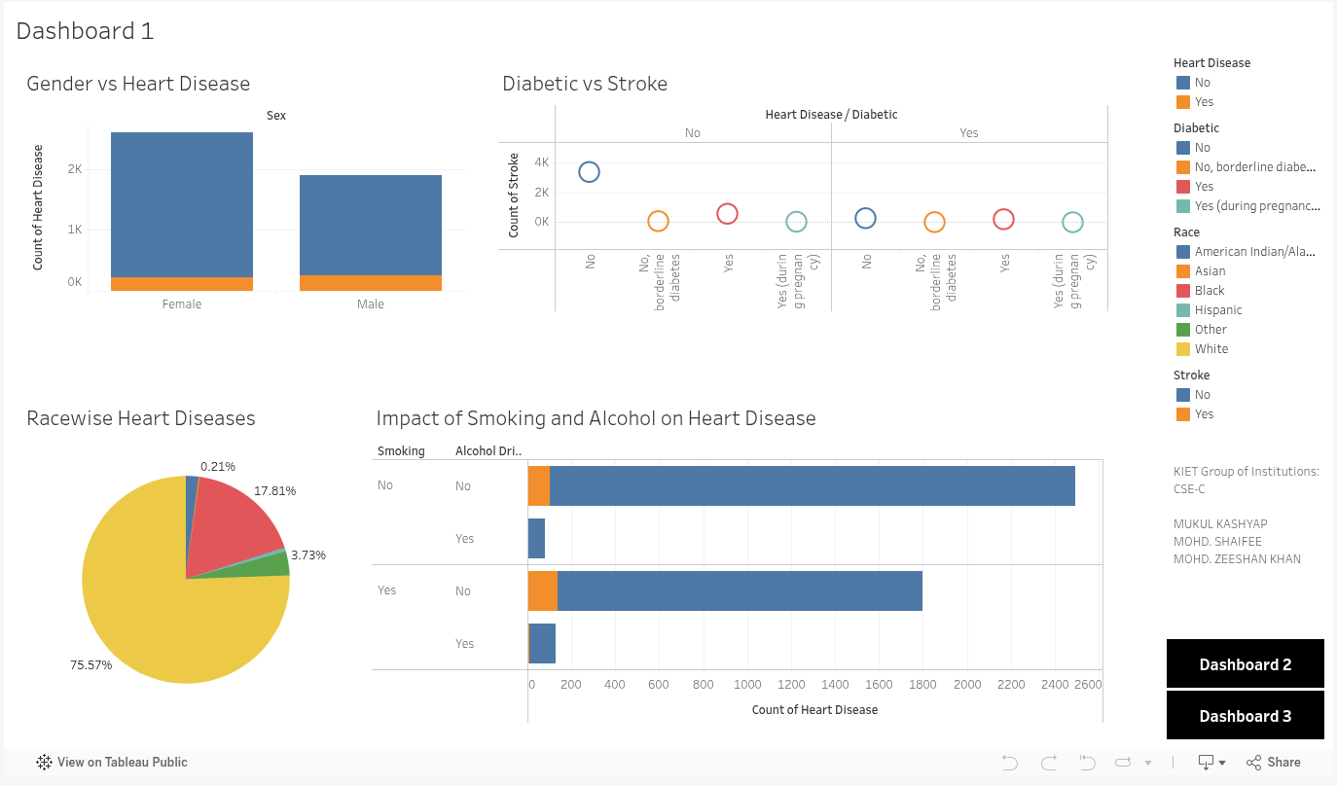

Dashboard 2 – Additional insights and comparisons between different health variables.
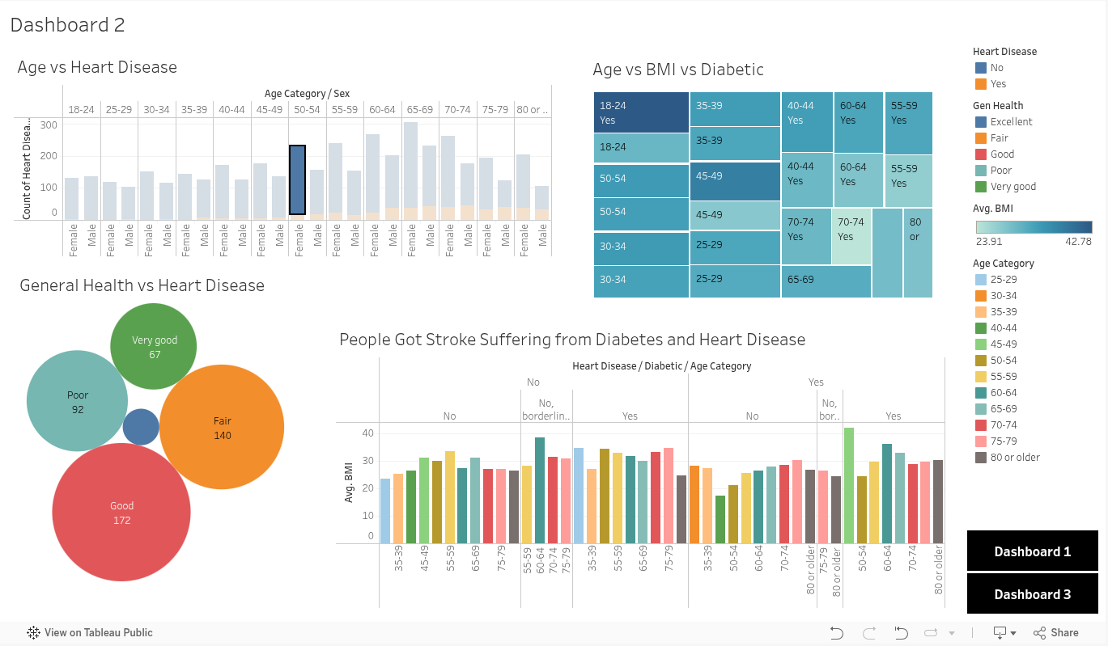

Dashboard 3 – Extended analysis of lifestyle factors affecting heart disease.
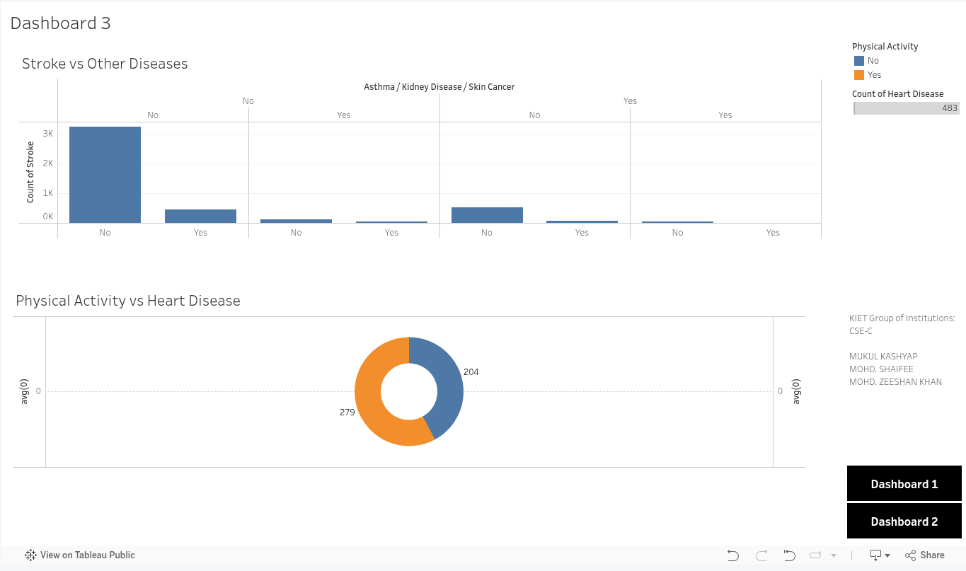

Tableau Links:
Story: https://public.tableau.com/app/profile/mukul.kashyap2734/viz/HeartDiseaseAnalysis_17729099648880/HeartDiseaseAnalysis?publish=yes
Dashboard 1: https://public.tableau.com/app/profile/mukul.kashyap2734/viz/HeartDiseaseAnalysis_17729099648880/Dashboard1
Dashboard 2: https://public.tableau.com/app/profile/mukul.kashyap2734/viz/HeartDiseaseAnalysis_17729099648880/Dashboard2
Dashboard 3: https://public.tableau.com/app/profile/mukul.kashyap2734/viz/HeartDiseaseAnalysis_17729099648880/Dashboard3

6. Key Insights
• Age plays a significant role in the occurrence of heart disease.
• Certain demographic groups show different prevalence levels.
• Lifestyle factors such as smoking and alcohol consumption show correlations with heart disease cases.
• Medical conditions like diabetes and stroke show relationships with heart disease outcomes.

7. Website Development
A simple website was developed using Flask to present the Tableau dashboards in a structured format. The website provides an overview of the project along with embedded interactive dashboards.
Website Link: https://heart-disease-analysis-3tau.onrender.com/
GitHub Repository: https://github.com/mukul-work/heart-disease-analysis

8. Technologies Used
• Tableau – Data visualization and dashboard creation
• Python – Backend development
• Flask – Web framework for hosting the dashboards
• HTML & CSS – Frontend structure and styling
• GitHub – Version control and project hosting

9. Conclusion
This project demonstrates how data visualization can be used to analyze health-related datasets and identify patterns in heart disease prevalence. The combination of Tableau dashboards and a Flask-based website allows the results to be presented in an interactive and accessible format.

